SCHOOL

Semester One Examination, 2013

Question/Answer Booklet

MATHEMATICS 2A
SOLUTIONS

Section Two:

Calculator-assumed

Student Number: In figures

In words

Your name

Time allowed for this section
Reading time before commencing work: ten minutes
Working time for this section: one hundred minutes

Materials required/recommended for this section

To be provided by the supervisor
This Question/Answer Booklet
Formula Sheet (retained from Section One)

To be provided by the candidate
Standard items: pens, pencils, pencil sharpener, eraser, correction fluid/tape, ruler, highlighters

Special items: drawing instruments, templates, notes on two unfolded sheets of A4 paper, and up to three calculators satisfying the conditions set by the Curriculum Council for this examination.

Important note to candidates

No other items may be used in this section of the examination. It is your responsibility to ensure that you do not have any unauthorised notes or other items of a non-personal nature in the examination room. If you have any unauthorised material with you, hand it to the supervisor before reading any further.

Structure of this paper

Section | Number of questions available | Number of questions to be answered | Working time (minutes) | Marks available | Percentage of exam
Section One:  Calculator-free | 7 | 7 | 50 | 50 | 33
Section Two:  Calculator-assumed | 12 | 12 | 100 | 100 | 67
 |  |  | Total | 150 | 100

Instructions to candidates

- The rules for the conduct of Western Australian external examinations are detailed in the Year 12 Information Handbook 2013. Sitting this examination implies that you agree to abide by these rules.

- Write your answers in the spaces provided in this Question/Answer Booklet. Spare pages are included at the end of this booklet. They can be used for planning your responses and/or as additional space if required to continue an answer.
- Planning: If you use the spare pages for planning, indicate this clearly at the top of the page.
- Continuing an answer: If you need to use the space to continue an answer, indicate in the original answer space where the answer is continued, i.e. give the page number. Fill in the number of the question(s) that you are continuing to answer at the top of the page.

- Show all your working clearly. Your working should be in sufficient detail to allow your answers to be checked readily and for marks to be awarded for reasoning. Incorrect answers given without supporting reasoning cannot be allocated any marks. For any question or part question worth more than two marks, valid working or justification is required to receive full marks. If you repeat an answer to any question, ensure that you cancel the answer you do not wish to have marked.

- It is recommended that you do not use pencil, except in diagrams.

Section Two: Calculator-assumed (100 Marks)
This section has twelve (12) questions. Answer all questions. Write your answers in the spaces provided.

Working time for this section is 100 minutes.

Question 8 (8 marks)
(a) Use your calculator to evaluate

(i) 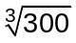, rounding your answer to one decimal place. (2 marks)

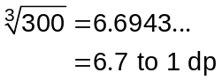

(ii) 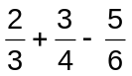, leaving your answer as a fraction. (2 marks)

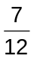

(iii) 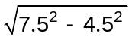 (2 marks)

6

(b) Use the formula 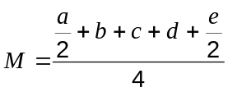 to find 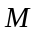 when 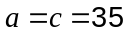, 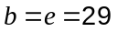 and 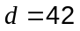.
(2 marks)
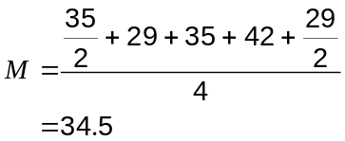

Question 9 (8 marks)
Some TV shows can be purchased and watched using the Internet. The pie charts below show the distribution of five types of TV show available from the Imazon and Atunes online stores.
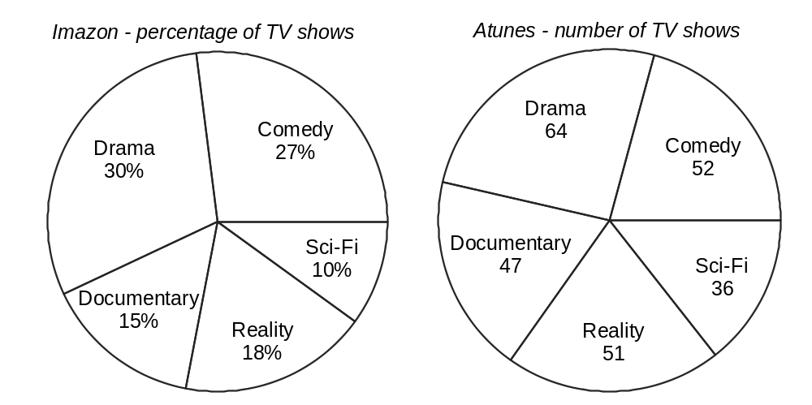

(a) What fraction of Atunes shows are Documentary? (1 mark)
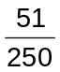

(b) What percentage of Atunes shows are Comedy? (2 marks)

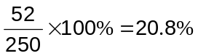

(c) What angle is the Reality sector of the Imazon pie chart? (1 mark)

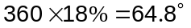

(d) Imazon have 32 Sci-Fi shows.

(i) How many Drama shows do they have? (2 marks)
Drama is 3x Sci-Fi for Imazon.

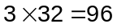 Drama shows

(ii) Which online store sells the most number of Documentary shows? Justify your answer. (2 marks)
Imazon, as they have 48 compared to Atunes 47.

Imazon - Doc is half of Drama: 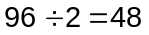

Question 10 (5 marks)
A typist can create documents at an average speed of 140 words per minute.

(a) How many words would be in a document if it took the typist three and a half hours to create? (2 marks)

(b) A document will contain 4 900 words when complete. How long will it take to type?
(1 mark)
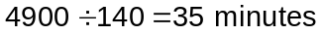

(c) The typist works for six hours a day. The first two documents she completes during one day contain 17 800 and 25 000 words. If she has to complete the last document within her working day, what is the maximum number of words that it can contain? (2 marks)
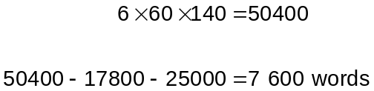

Question 11 (13 marks)
The foot lengths of 28 adult males are shown below in centimetres.

25.1 | 24.1 | 25.4 | 28.3 | 25.6 | 27.2 | 29.3
24.5 | 27.0 | 25.7 | 29.8 | 24.0 | 26.3 | 27.4
27.8 | 24.8 | 27.1 | 28.0 | 26.4 | 27.3 | 23.5
25.3 | 28.7 | 26.4 | 26.7 | 26.1 | 28.9 | 27.4

(a) Find the shortest, longest and range of the above lengths. (3 marks)
Shortest: 23.5 cm

Longest: 29.8 cm

Range: (29.8-23.5) 6.3 cm

(b) Complete the grouped frequency table below for the lengths. (3 marks)

Foot length (cm) | Tally | Frequency
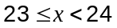 |  | 1
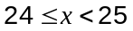 |  | 4
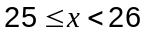 |  | 5
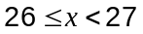 |  | 5
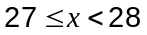 |  | 7
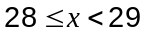 |  | 4
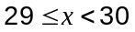 |  | 2

(c) State the modal class. (1 mark)
cm

(d) Calculate the mean of the lengths using the grouped data table. (2 marks)
Mean length is 26.7 cm (1 dp)

(e) Construct a frequency histogram for the grouped data. (3 marks)

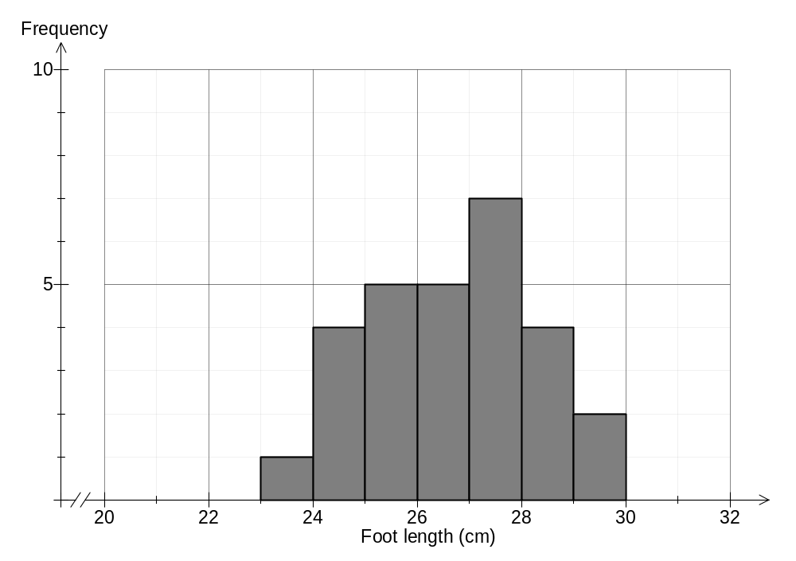

(f) Use the histogram to describe the spread of the data. (1 mark)
Suggest that the data is one of

- tightly packed

- clustered together

- etc

Question 12 (9 marks)
A shop sells the same type of jam in three sizes:

220 g for $3.74 | 350 g for $5.60 | 500 g for $8.25

(a) List the sizes in order of best value for money, from best to worst. Show calculations to support your order. (3 marks)
Price per gram:

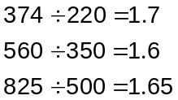

So 350 g is best value, then 500 g and 220 g is worst.

(b) The shop buys the 500 g jars from a wholesaler in boxes of 24 for $114.

(i) What profit is made when the shop sells one 500 g jar? (2 marks)
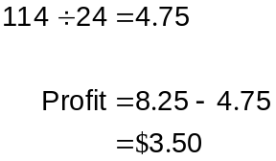

(ii) Calculate the percentage profit on a 500 g jar of jam. (2 marks)

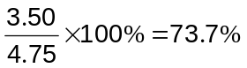

(c) The selling price includes GST of 10%. How much of the selling price for a 220 g jar of jam is GST? (2 marks)
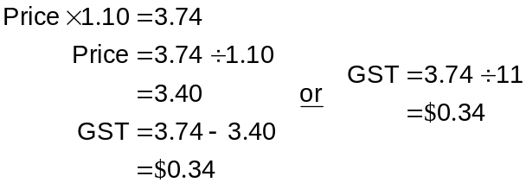

Question 13 (10 marks)
A small city carried out a survey of adults in 2006 with the following results:

 | Males |  |  | Females
Marital Status | Living with parent(s) | Not living with parent(s) | Total | Living with parent(s) | Not living with parent(s) | Total
Never married | 2104 | 562 | 2666 | 1936 | 342 | 2278
Married | 593 | 2612 | 3205 | 598 | 2605 | 3203
Widowed | 7 | 122 | 129 | 20 | 670 | 690
Divorced | 26 | 86 | 112 | 33 | 166 | 199
Total | 2730 | 3382 | 6112 | 2587 | 3783 | 6370

(a) How many

(i) females were widowed and not living with their parent(s)? (1 mark)
670

(ii) males were married? (1 mark)
3205

(iii) adults were never married? (1 mark)
4944

(iv) adults were surveyed? (1 mark)
12482

(b) What percentage of males were not living with parent(s)? (2 marks)
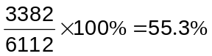

(c) What fraction of married adults were living with parent(s)? (2 marks)
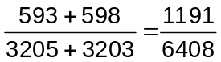

(d) Express the ratio of males to females of those divorced and not living with parent(s) in the form 1 to , rounding your value for to two decimal places. (2 marks)
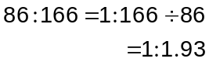

Question 14 (6 marks)
(a) Water is poured at a steady rate into four containers with different cross-sections.
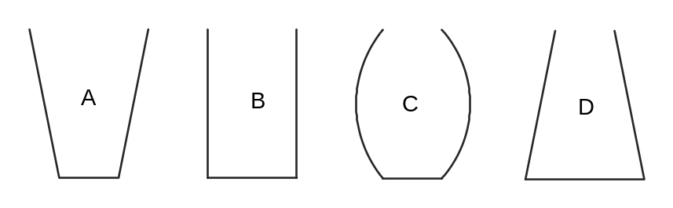

The height of the water level is plotted against time in the four graphs below.

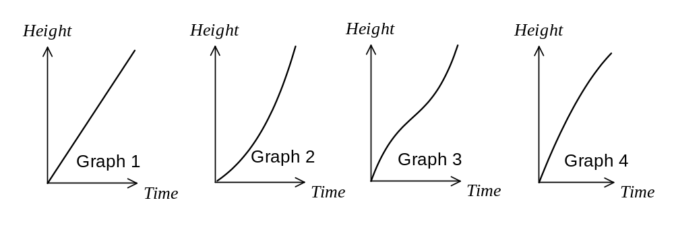

Match each container with the graph that best represents the height of the water in that container against time. (4 marks)

Container | A | B | C | D
Graph | 4 | 1 | 3 | 2

(b) Water is poured at a steady rate into the container below. Sketch a graph that shows the height of water in this container against time. (2 marks)

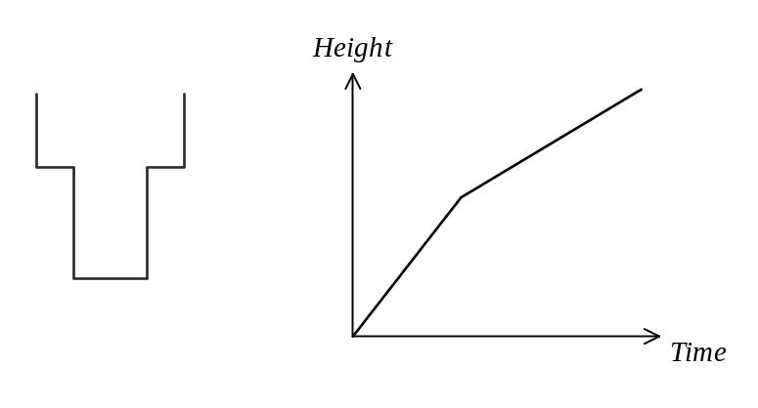

Question 15 (5 marks)
A tall, thin tree is growing in a flat and level lawn. The sun was out and the length of the shadow of the tree was 2.3 m.

(a) Draw a sketch of the tree and it's shadow. (1 mark)

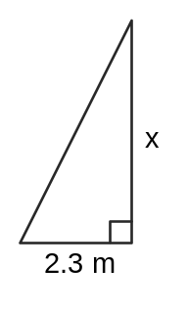

At the same time, a pole that was 1.8 m long was held vertically next to the tree. The length of its shadow was 0.45 m.

(b) Draw a sketch of the pole and its shadow. (1 mark)
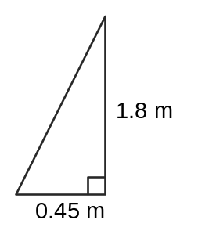

(c) Determine the height of the tree. (3 marks)
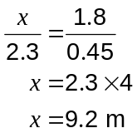

Question 16 (9 marks)
(a) A shopper buys 8 packets of the same cereal and after a $1 discount per packet, pays a total of $46.

(i) If the price of one packet of the cereal before discount is $, write the above information as an equation. (2 marks)
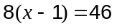

(ii) What is the price of one packet of the cereal? (1 mark)
$6.75

(iii) What is the cost of five packets of the cereal, after a $1 per packet discount?
(1 mark)

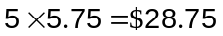

(b) A number of students went on a field trip, of which were boys.

(i) There were 131 students altogether. Use this information to write an expression for the number of girls. (1 mark)
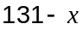

(ii) The number of girls was equal to seventeen less than three times the number of boys. Use this information to write another expression for the number of girls.
(1 mark)
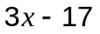

(iii) Use your answers from (i) and (ii) to write an equation that can be solved to find .
(1 mark)
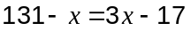

(iv) How many boys and how many girls went on the field trip? (2 marks)
Use solve on calculator to get 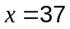.

So there are 37 boys and 94 girls.

Question 17 (10 marks)
This dot frequency graph shows the average weekly time spent on homework (to the nearest hour) by a random selection of Year 11's from school X in Western Australia.
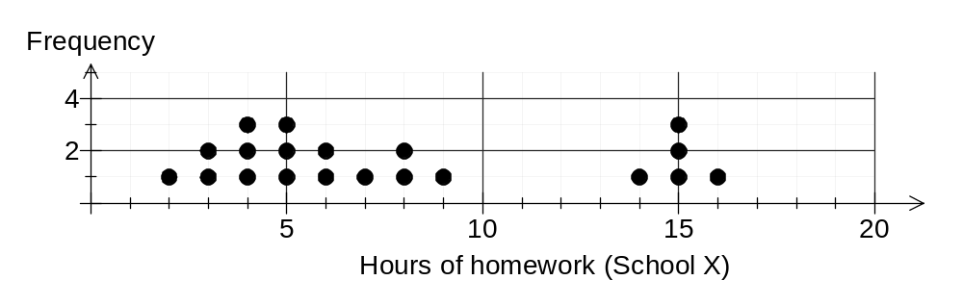
(a) How many students were surveyed? (1 mark)
20

(b) What percentage of these students spent five or more hours on homework? (2 marks)
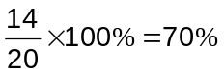

A similar selection of Year 11's from school Y returned the following times:

2, 9, 10, 3, 1, 0, 1, 4, 2, 14, 12, 2, 5, 4, 4, 7, 2, 0, 7 and 1.

(c) Construct a dot frequency graph for these students on the axes below. (3 marks)
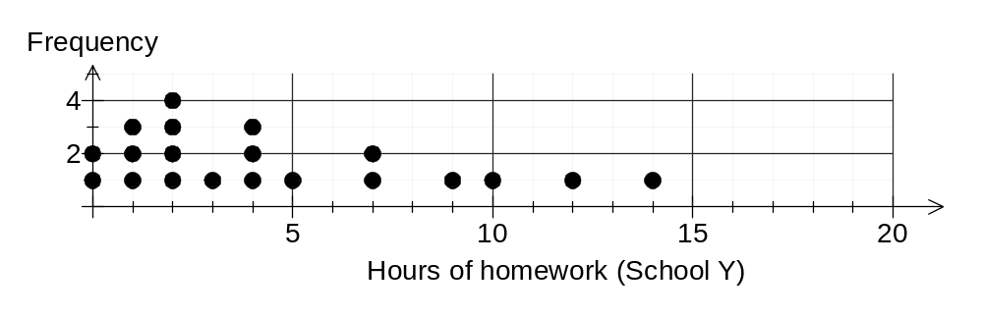
(d) What percentage of students from school Y spent fewer than five hours on homework?
(2 marks)
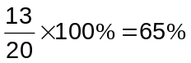

(e) Briefly describe two differences between the datasets for school X and school Y.
(2 marks)
- 70% of students from X spent 5 or more hours compared to just 35% from Y
- median for X higher than median for Y (6 v 3.5 hours)
- mean for X will be higher than mean for Y
- X has two clusters with gap but Y less tightly packed
- etc

Question 18 (8 marks)
Triangle ABC has been transformed to A'B'C' and also to A''B''C''.
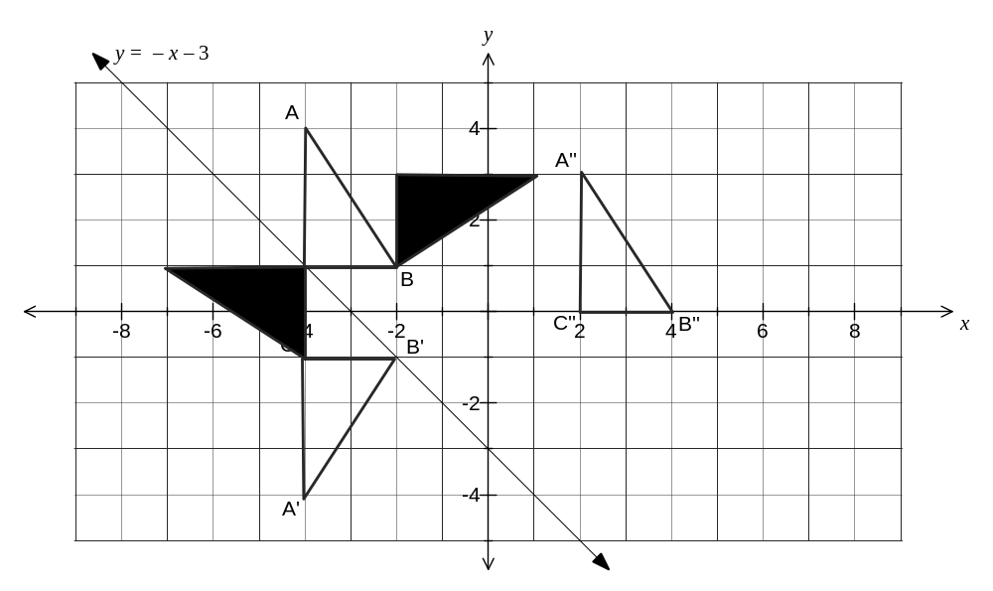
(a) Describe the transformation of triangle ABC to

(i) A'B'C'. (2 marks)
Reflection

in the x-axis

(ii) A"B''C''. (2 marks)
Translation

of 6 units right and 1 unit down

(c) Draw on the diagram above the resulting triangle when

(i) ABC is reflected in the dotted line 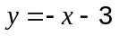. (2 marks)

(ii) ABC is rotated 90° clockwise about B(-2, 1). (2 marks)

Question 19 (9 marks)
(a) A 2.7 m long ladder leans against a vertical wall as shown. The top of the ladder is 2.4 m above the horizontal ground.

(i) Determine how far the base of the ladder is from the wall, rounded to one decimal place. (2 marks)

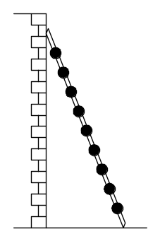
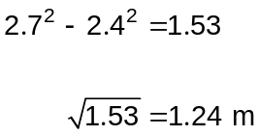

(ii) If the top of the ladder slips 30 cm down the wall, calculate how far the base of the ladder slips away from the wall. (4 marks)
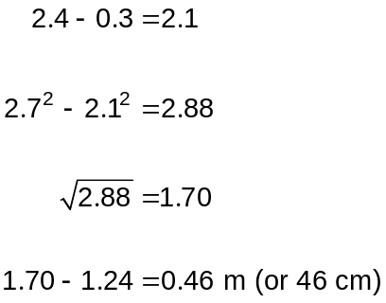

(b) A right-angled triangle has a hypotenuse of length 75 cm and two other sides, both of length , as shown in the diagram. Determine . (3 marks)

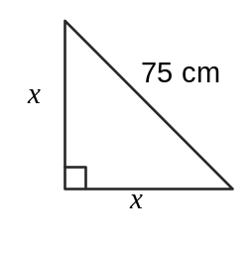
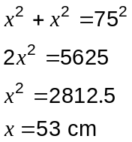

This examination paper may be freely copied, or communicated on an intranet, for non-commercial purposes within educational institutes that have purchased the paper from WA Examination Papers provided that WA Examination Papers is acknowledged as the copyright owner. Teachers within purchasing schools may change the paper provided that WA Examination Paper's moral rights are not infringed.

Copying or communication for any other purposes can only be done within the terms of the Copyright Act or with prior written permission of WA Examination papers.

Published by WA Examination Papers
PO Box 445 Claremont WA 6910

